Thermal Imaging
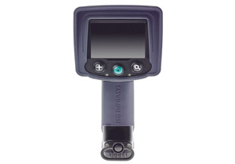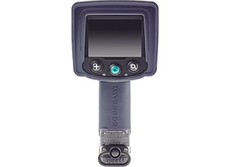

X380 3 Button Thermal Imaging Camera X380N NFPA COMPLIANT

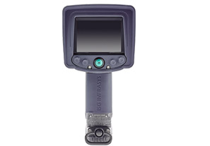

X380 5 BUTTON CAMERA

TACTICAL SEARCH & RESCUE

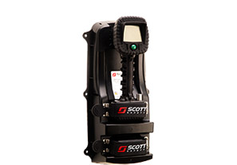

EAGLE ATTACK THERMAL IMAGING CAMERA

